**OBO DATA GATHERING – BAKKEN & OKHLHOMA**

User Manual Automation Script

1. **Introduction : -**

This document provide step by step instructions for using the Python Selenium script that automates the OBO Data Gathering process in the PDS WELL DATA EXCHANGE System.

This is weekly Request we have to raise request on first working day of week and complete it on last working day of the week, eventually we have to send Acknowledgment and Completion mails.

1. **Script folder structure :-**

I the below image there is folder structure of Automated Script of Bundled of python file in EXE file as a Executable to run in any windows system with install any Python Dependencies.

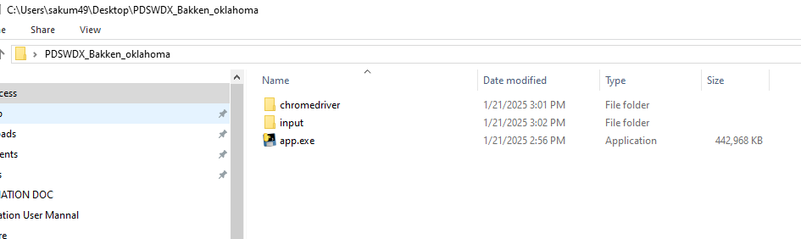

1. First you have to copy the Script folder from LAN PATH: “**K:\global\SSDM\USER_FOLDER\Automation\PDSWDX_Bakken_oklahoma”**  in VDI or local system where you able to access the <https://www.pdswdx.com/login>
2. Once Copy the Script on Local System or VDI open the input folder and click on input.xlsx file to update the Details of LAN folder path tracker sheet path and PSDWDX login Details.
3. Once you open the input file there is dropdown list for which region Report you want to trigger. There is few column we need to update for trigger the report .
4. 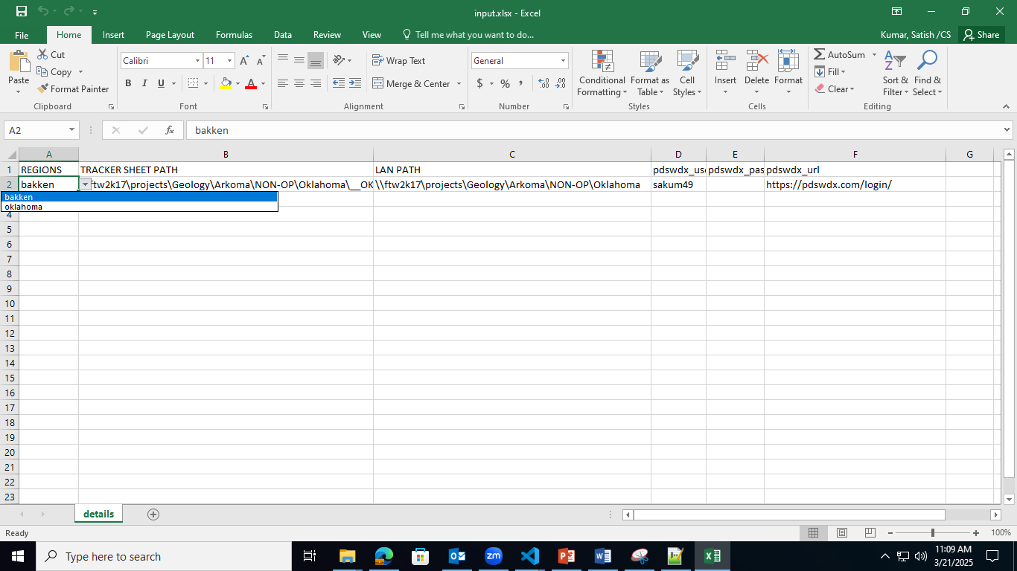
   1. REGIONS : This column is a drop down list there is two regions , BAKKEN & OKHLHOMA .

If we want to complete the weekly report of Bakken than we have to select the Bakken otherwise you to complete the report of OKHLHOMA select Oklahoma.

Based on the REGIONS you have to select the LAN PATH Column and Tracker sheet column dropdown list of path.

* 1. There is PDSWDX login User name and Password Column you have to update the pdswdx_username and pdswdx_password save the file and close.

1. **Trigger the app.exe file:** For trigger app.exe file we need to open the Command Prompt.
2. Press CTRL + R than press Enter Button to open CMD prompt.

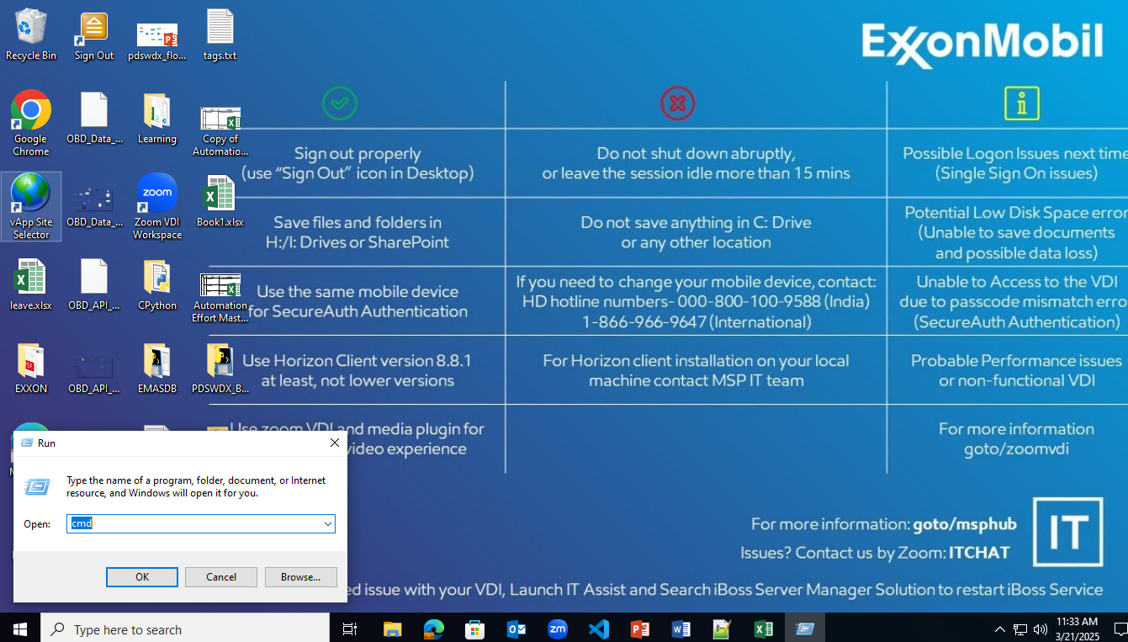

Once open the CMD prompt track you folder path of Script.

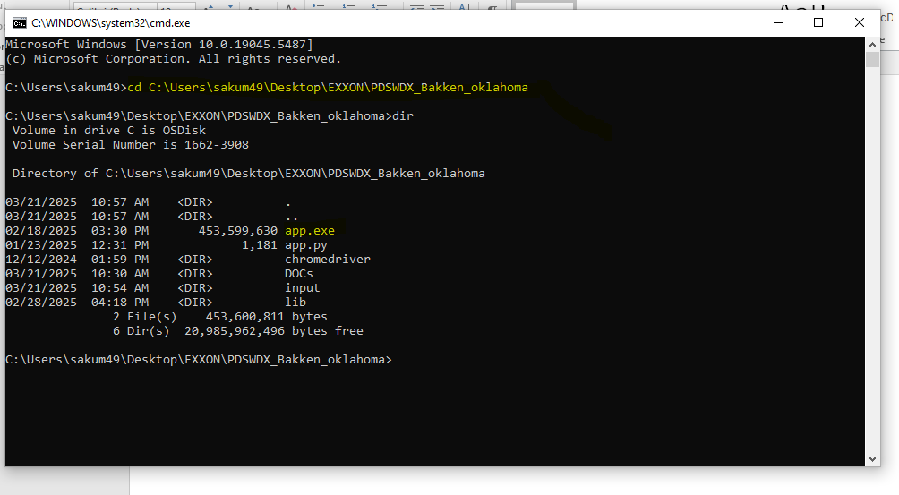

1. Now trigger the app.exe file of the list of dir folder.

For trigger the report first we have to decide from which date range we want to complete the report.

Example: if you want to complete the report of March Second week report to you have to select the Date Range: 3/17/2025 to 3/21/2025.

Date format should be: m/d/Y if date day or month in Single number like day = 1,to 9 than put only 3/21/2025 do not put 03/21/2025 or 3/05/2025.

1. **Run the Script :** put the command on cmd like : app.exe start_date(m/d/Y) (end_date) m/d/y)

Fallow the below screenshot for command.

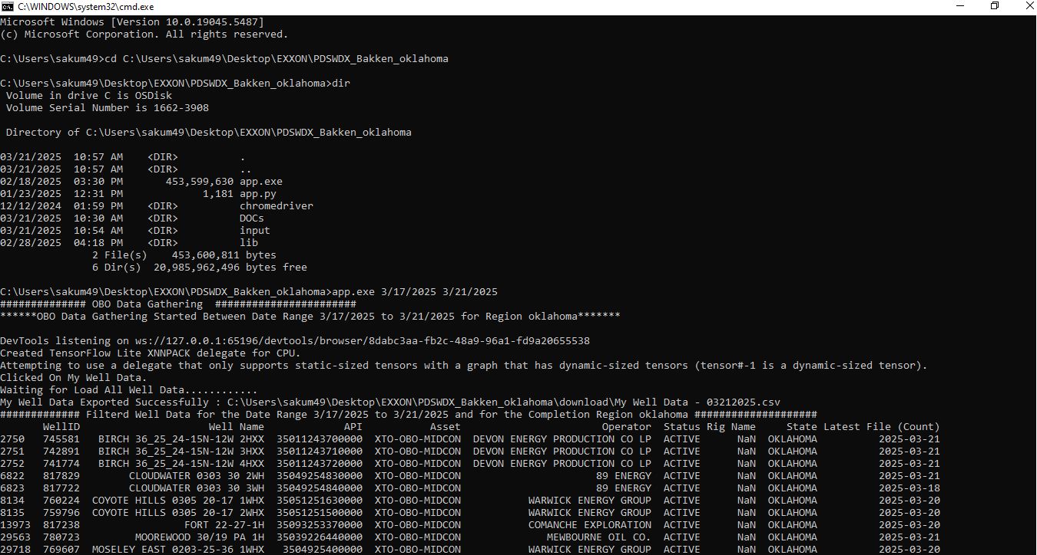

1. Once script stared automatically PDSWDX website will open and do the all process to export the Well Name and search well copy the well on lan folder and update the tracker sheet.
2. Once script successfully done open tracker sheet and filter based on date range and shared the completion email.
3. **Contact and Support**

For technical support, contact

Email : [satish.kumar3@exxonmobil.com](mailto:satish.kumar3@exxonmobil.com)

Phone : +91 - 7011585550